Sprint 3 Plan

Product Name : UpToDate

Team Name: UpToDaters

Release Name : UpToDate

Release Date : 3/19/18

Revision Number : 2

Revision Date : 3/4/18

Goal: Implement Twitter and Youtube

Task Listing

* User Story 1: As a user, I want to see what’s trending on Youtube (13 points)
  + Task 1: Connect the Youtube API (5 hours)
  + Task 2: Be able to dynamically crawl Youtube based on user query (3 hours)
  + Task 3: Display the results (2 hours)
* User Story 2: As a user, I want to see what’s trending on Twitter (13 points)
  + Task 1: Connect the Twitter API (5 hours)
  + Task 2: Be able to dynamically crawl Twitter based on user query (3 hours)
  + Task 3: Display the results (2 hours)
* User Story 3: As a user, I want to be able to view videos without going to Youtube
  + Task 1: Add embedding to the results(2 hours)

Team Roles

* Team Member Manav Sharma: Product Owner
* Team Member Tariq Anees: Scrum Master
* Team Member Andrew Boyadjiev: Developer
* Team Member Arthur Kung: Developer
* Team Member Tommy Tran: Developer
* Team Member Vanessa Tan: Developer

Initial Task Assignment

* Team Member Manav Sharma will work on user story #1 and his task is to implement Youtube’s API
* Team Member Tariq Anees will work on user story #1 and #2 and his task is to crawl based on search term
* Team Member Andrew Boyadjiev will work on user story #1 and #2 and his task is to help display the results
* Team Member Arthur Kung will work on user story #2 and his task is to implement Twitter
* Team Member Tommy Tran will work on user story #1 and his task is to implement Youtube
* Team Member Vanessa Tan will work on user story #1 and her task is to implement Twitter

Burn Up Chart

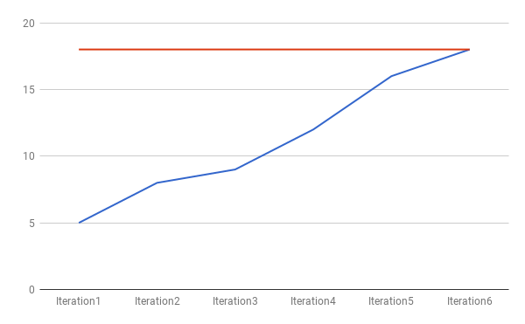

Scrum Times

* Monday at 11:30 am (TA visit)
* Wednesday at 9:00 am
* Friday at 9:00 am

Scrum Board

